

**Excel Assignment - 21**

1. Write a VBA code to enter your name in A1 Cell using Input Box and once you enter the name display a message box that says the name has been entered.

Answer: 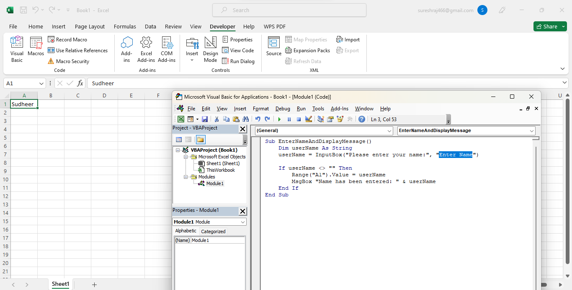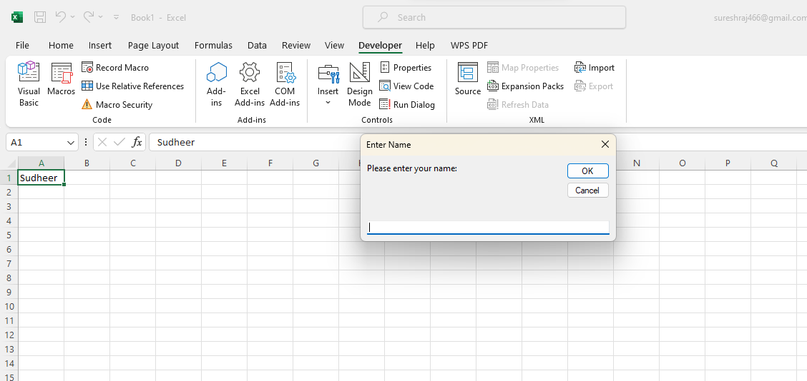

2. What are Userforms? Why are they used? How to fill a list box using for loop.

Answer:

User forums are dialog boxes or windows that you can create in Excel VBA. They provide an interactive way for users to input data, make selections, and perform various actions. User forums are used to create a more user-friendly interface for Excel applications.

To fill a list box using a For loop in a Userform: Assuming you have a userform named "UserForm1" and a ListBox named "ListBox1" on it

Private Sub UserForm_Initialize()

Dim i As Integer

For i = 1 To 10

ListBox1.AddItem "Item " & i

Next i

End Sub

3. What is an array? Write a VBA code to enter students and their marks from the below table.

Answer: An array is a collection of variables of the same data type that are stored together under a single name. In VBA, arrays can hold multiple values in a single variable. Here's an example code to enter students and their marks into Excel using arrays:

Option Explicit

Sub showMarks()

Dim lastRow As Integer, idfound As String, rowno As Integer

idfound = "No"

lastRow = Worksheets("Source").Cells(Rows.Count, 1).End(xlUp).Row

Sheets("destination").Range("A5:K5").ClearContents

If Sheets("destination").Range("B1") = vbNullString Then

MsgBox "Student ID is blank.", vbInformation

Exit Sub

End If

For rowno = 2 To lastRow

If Sheets("destination").Range("B1") = Sheets("source").Range("A" & rowno) Then

idfound = "yes"

Sheets("source").Rows(rowno).Copy Sheets("destination").Range("A5")

Exit Sub

End If

Next

If idfound = "No" Then

MsgBox "ID not found", vbInformation

End If

End Sub

4. Use the following data to create a pie chart using VBA code. Use Font - ‘Times new Roman’, Size -14, Bold, Title - Piechart’ and you are per to use colours as per your taste.

Answer:

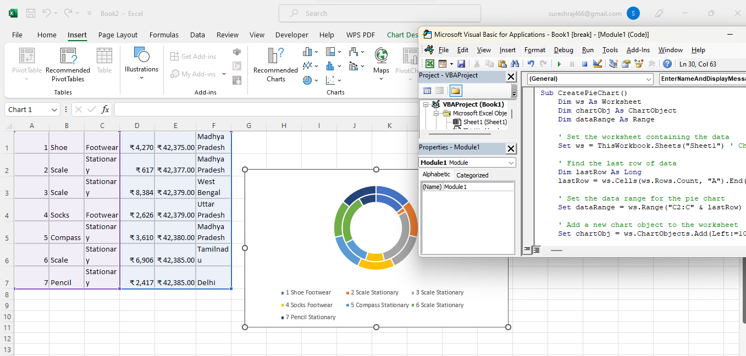

5. Check the dataset in the link given below and create a pivot table using VBA showing the sales for the year from stationary category.

Answer: 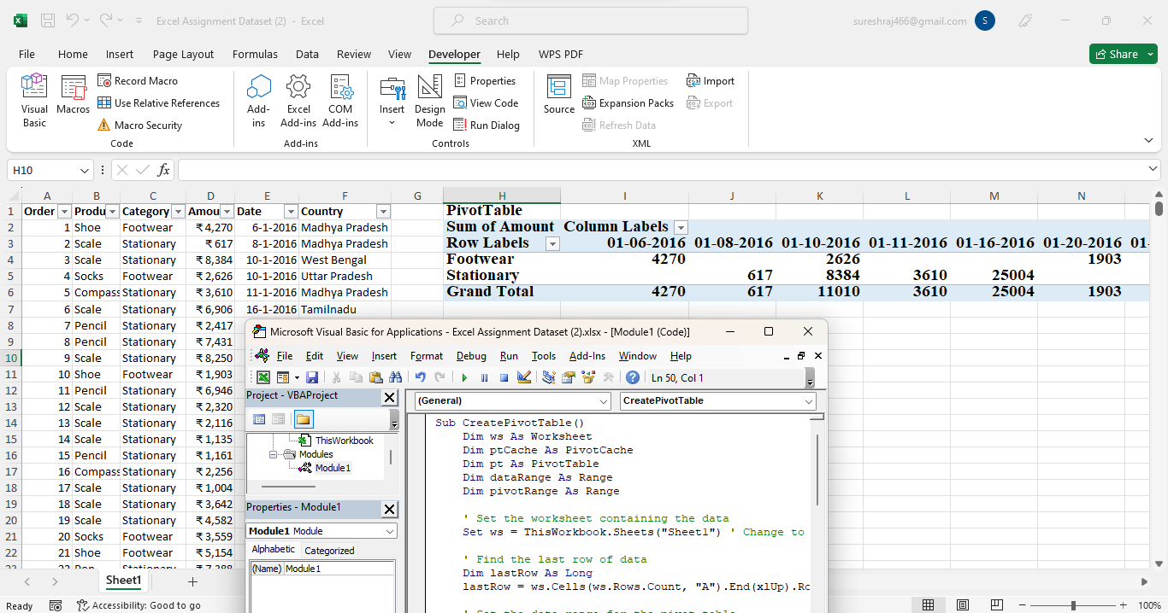

https://docs.google.com/spreadsheets/d/1IRSEnmgz8Ro276- GslknRNk0zlrB5CZH1YrnT71kqFM/edit?usp=sharing

Sub CreatePivotTable()

Dim ws As Worksheet

Dim ptCache As PivotCache

Dim pt As PivotTable

Dim dataRange As Range

Dim pivotRange As Range

' Set the worksheet containing the data

Set ws = ThisWorkbook.Sheets("Sheet1") ' Change to your sheet name

' Find the last row of data

Dim lastRow As Long

lastRow = ws.Cells(ws.Rows.Count, "A").End(xlUp).Row

' Set the data range for the pivot table

Set dataRange = ws.Range("A1:F" & lastRow) ' Assuming data is in columns A to F

' Create a new pivot cache

Set ptCache = ThisWorkbook.PivotCaches.Create(SourceType:=xlDatabase, SourceData:=dataRange)

' Create a new pivot table on a new worksheet

Set pt = ptCache.CreatePivotTable(TableDestination:=ws.Cells(2, 8), TableName:="PivotTable1")

' Set up the pivot table fields

With pt.PivotFields("Category")

.Orientation = xlRowField

.Position = 1

End With

With pt.PivotFields("Date")

.Orientation = xlColumnField

.Position = 1

.NumberFormat = "mm/dd/yyyy" ' Format the date column

End With

pt.AddDataField pt.PivotFields("Amount"), "Sum of Amount", xlSum ' Sum the Amount column

' Set the pivot table range for formatting

Set pivotRange = ws.Range("H1").CurrentRegion

' Apply formatting to the pivot table

pivotRange.Font.Name = "Times New Roman"

pivotRange.Font.Size = 14

pivotRange.Font.Bold = True

pivotRange.Cells(1, 1).Value = "PivotTable"

' Autofit columns for better visibility

pivotRange.Columns.AutoFit

End Sub

6. Write step by step procedure to protect your workbook using a password.

Answer: Select **File** > **Info**.

1. Select the **Protect Workbook** box and choose **Encrypt with Password.**
2. Enter a password in the **Password** box, and then select **OK**.
3. Confirm the password in the **Reenter Password** box, and then select **OK**.